Submission of Amendment (variation) to a MUHEC approved study
The Chairperson of the Committee has the power to approve amendments when these are of a minor nature. Amendments that require major changes now result in the submission of a new application, which must be considered by a Committee at a Human Ethics Committee meeting (MUHEC). A Chairperson may request a new application is submitted after review of a minor amendment application.

For amendments to Low Risk Notifications (i.e., a project not approved by a MUHEC), please contact the Ethics Secretariat through gmhumeth@massey.ac.nz for further information.

Please refer to the flowchart below, when assessing if your amendment is major or minor:
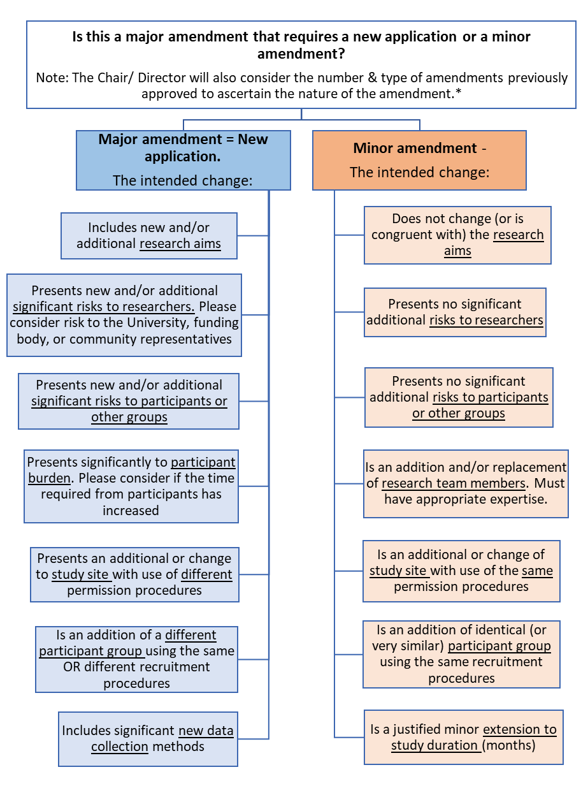
*If your intended amendment does not fit a criteria as outlined above, please contact the Ethics Secretariat through gmhumeth@massey.ac.nz for further guidance.
Minor Amendment (variation) form to a MUHEC Approved Study

Researchers must only use the following form for Minor Amendments (as established by the Flowchart above). If it is established that your intended amendment is major, you will need to submit a new application through the Research Master system (https://rme.massey.ac.nz/).

Primary Applicant Name:

Application ID:

Has your project title changed? (Please select one)
- Yes
- No
If yes, please provide the new title of your project:

Please provide a brief summary of your research proposal, based on your original ethics application:

Does your amendment involve any of the following changes? (Please select any that apply)
- Change to completion date
- Change to personnel
- Minor change to original research aims
- Minor change to research instruments/participant material
- Change to research methodology
- Change to recruitment of participants
- Other

Approximate new completion date (if applicable):

Please list the additional members of the research team and relevant expertise for involvement in this project (if applicable):

Does your amendment involve the addition of children as participants? (Please select one)
- Yes
- No
NB: Selecting ‘yes’ may require the submission of a new application. Inclusion of Child participants under the age of seven or under the age of 16 without active parental consent will result in a new application.

Will changes include research being conducted using Massey Students not previously approved for: (Please select one)
- Yes
- No
NB: Selecting ‘yes’ may require the submission of a new application. Please refer to the Massey Decision Chart regarding research on students (at page 12).

Please provide details of the changes proposed to your original ethics application:

Why do you wish to make these changes?

Impact of amendment on research participants
This section requires you to consider the way in which your proposed amendments may impact upon the ethical issues raised in your original application. Specifically, we ask you to outline the effect (if any) of your amendments on the following areas, and how you intend to deal with them. Please consider if your amendment affects any of the following:

1) Outcome of your research? (Please select one)
- Yes
- No
If yes, please provide further information on how your amendment effects the outcome of the research:

2) Current or future applications for funding? (Please select one)
- Yes
- No
If yes, please provide further information on how your amendment effects the current or future funding of the research

3) Recruitment of participants (e.g., site location, quantity, cohort, methods)? (Please select one)
- Yes
- No
If yes, please provide further information on how your amendment effects the recruitment of participants (e.g., site location, quantity, cohort, methods):

4) Change to the risk of harm (increase or decrease) to participants and/or researchers? (Please select one)
- Yes
- No
If yes, please provide further information on how your amendment changes the risk of harm (increase or decrease) to participants and/or researchers
NB: Selecting ‘yes’ may require the submission of a new application.

5) Relationships (if any) between researchers and participants (e.g., is there a conflict of interest?) (Please select one)
- Yes
- No
If yes, please provide further information on how your amendment relationship between researchers and participants (e.g., is there a conflict of interest?)

6) Consent from participants? (Please select one)
- Yes
- No
If yes, please provide further information on how your amendment effects the consent process of participants

7) Data collection, interpretation, storage and/or disposal? (Please select one)
- Yes
- No
If yes, please provide further information on how your amendment effects the collection, interpretation, storage and/or disposal of research data

8) Privacy and confidentiality of participants? (Please select one)
- Yes
- No
If yes, please provide further information on how your amendment effects the privacy and confidentiality of participants

9) Are you required to submit requests for amendment to any external bodies to Massey (e.g., the HDEC, HRC or another University)? (Please select one)
- Yes
- No
If yes, please provide further information regarding this process (i.e., which external bodies will be submitted to?)

10) Are there any other relevant ethical issues in relation to the proposed amendment? (Please select one)
- Yes
- No
If yes, please provide further information regarding these relevant ethical issues

Amendment attachments
Please attach any updated forms and public documentation for this amendment. These might include:
- Study Protocol
- Participant Information and Consent Forms
- Advertising Materials
- Invitation Letter
- Emails to participant organisations
- Questionnaire/Survey materials
- Interview Questions
- Focus Group protocol
- Funding agreements

